CMPG322
Exercise 5.1 – PERT/CPM
- Tom Holland, the managing director of the Trigger-Happy gun shop is involved in planning a scientific research project on the impact of different lockdown regulations on sports hunting in South Africa. The activities required for this project and the optimistic, most likely, and pessimistic time estimates are displayed in the following table.
ACTIVITY | IMMEDIATE PREDECESSORS | OPTIMISTIC TIME (weeks) | MOST LIKELY TIME (weeks) | PESSIMISTIC TIME (weeks)
A | — | 3 | 4 | 5
B | — | 3 | 3 | 3
C | A | 2 | 3 | 4
D | B | 1 | 3 | 5
E | B | 4 | 4 | 4
F | C | 2 | 2 | 2
G | D, E | 4 | 5 | 6
H | F, G | 3 | 4 | 5
Create a PERT/CPM network to help Tom find the critical path and project completion time.

- Sid Davidson is the personnel director of Babson and Willcount, a company that specializes in consulting and research. One of the training programs that Sid is considering for the middle-level managers of Babson and Willcount is leadership training. Sid has listed a number of activities that must be completed before a training program of this nature could be conducted. The activities, immediate predecessors and activity times appear in the following table:
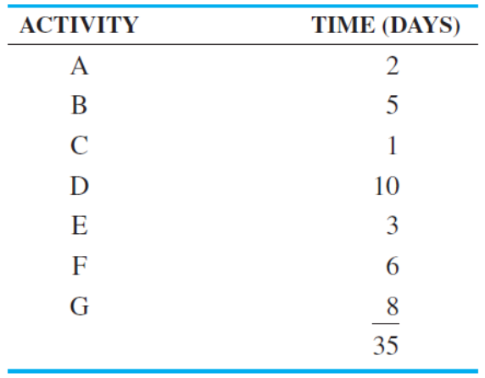
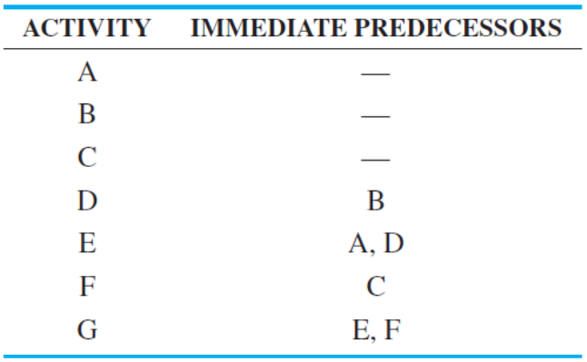

Develop a network for this problem and determine the total project completion time and the critical path(s).

- A political campaign manager must coordinate several activities in order to be prepared for an upcoming election. The following table describes the relationships among the activities that need to be completed, as well as the estimated times.
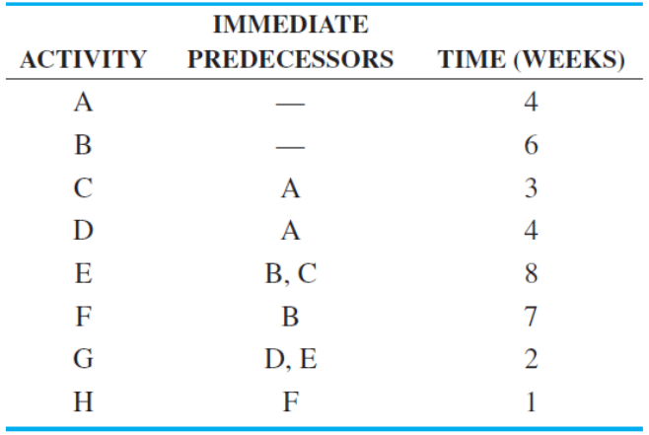
Develop a network for this problem and determine the total project completion time and the critical path(s).

- A marketing firm is developing a new Web-based media campaign for a client. The following table describes the relationships among the activities that need to be completed.
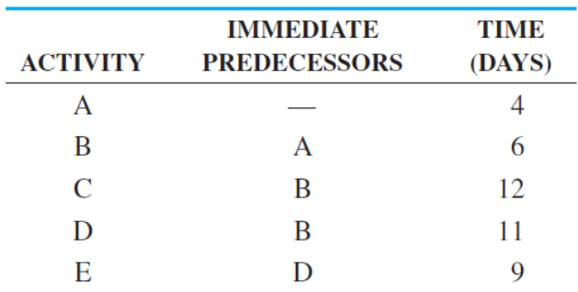
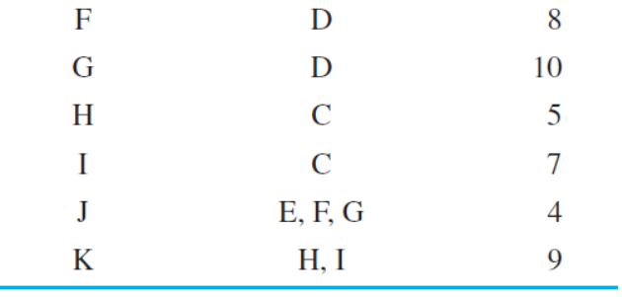
Develop a network for this problem and determine the total project completion time and the critical path(s).

- The Laurenster Corporation is getting into the construction business. A list of activities and their optimistic, most likely, and pessimistic completion times are given in the following table for the next construction project.
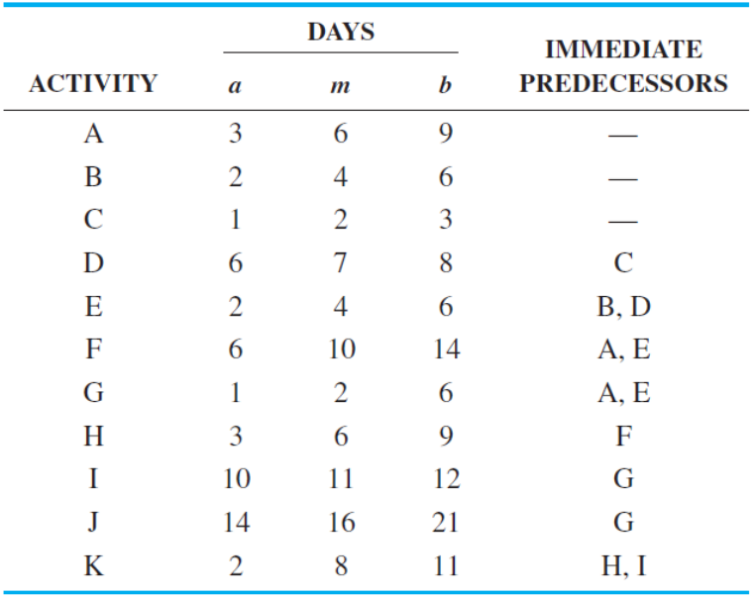
- Develop a project network for this problem.
- Determine the expected duration and variance for each activity.
- Determine the ES, EF, LS, LF, and slack time for each activity. Also determine the total project completion time and critical path(s).
- What is the probability that this job will finish in 38 days or less?

- The Laurenster Corporation needs to set up an assembly line to produce a new product. The following table describes the relationships among the activities that need to be completed for this product to be manufactured.
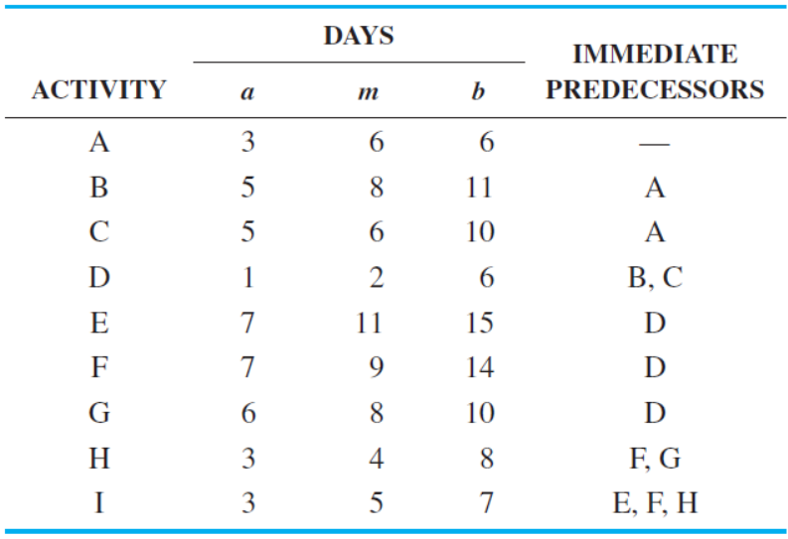
- Develop a project network for this problem.
- Determine the expected duration and variance for each activity.
- Determine the ES, EF, LS, LF, and slack time for each activity. Also determine the total project completion time and the critical path(s).
- Determine the probability that the project will be completed in 34 days or less.
- Determine the probability that the project will take longer than 29 days.

